AREA AND CIRCUMFERENCE OF CIRCLES
Pearson Edexcel - Tuesday 19 May 2020 - Paper 1 (Non-Calculator) Higher Tier
1.
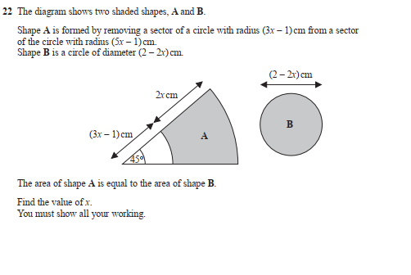
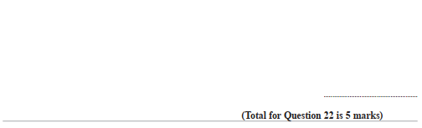

Pearson Edexcel - Monday 8 June 2015 - Paper 2 (Calculator) Higher Tier
2.
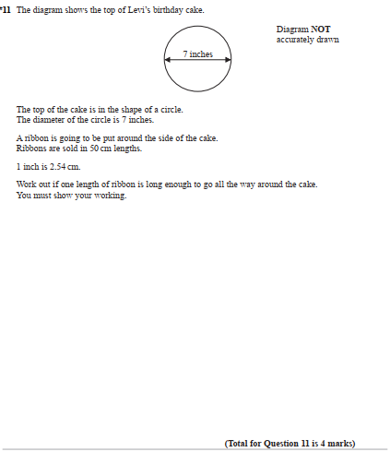

Pearson Edexcel - Friday 13 June 2014 - Paper 2 (Calculator) Higher Tier
3.

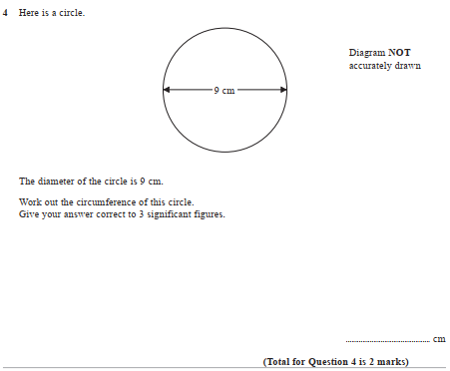

Pearson Edexcel - Friday 8 November 2013 - Paper 2 (Calculator) Higher Tier
4.
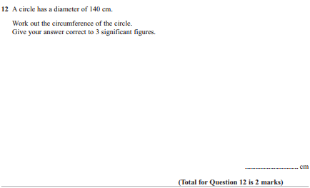

Pearson Edexcel - Monday 4 March 2013 - Paper 2 (Calculator) Higher Tier
5.
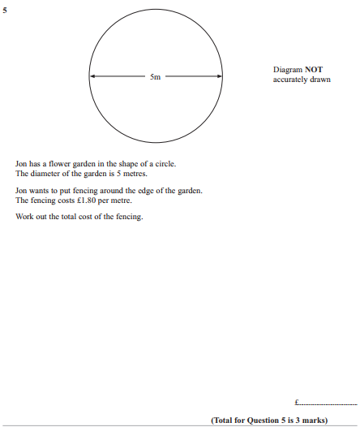

Pearson Edexcel - Monday 14 November 2011 - Paper 4 (Calculator) Higher Tier
6.
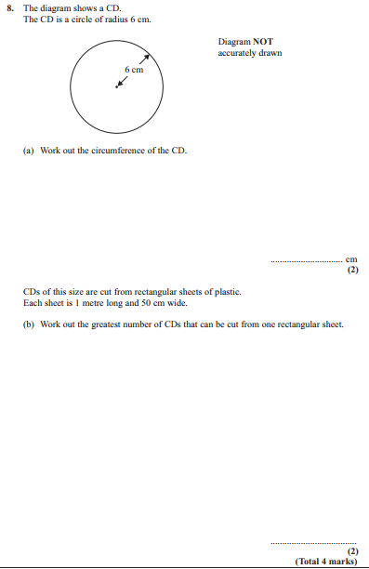

Pearson Edexcel - Tuesday 9 November 2010 - Paper 3 (Non-Calculator) Higher Tier
7.
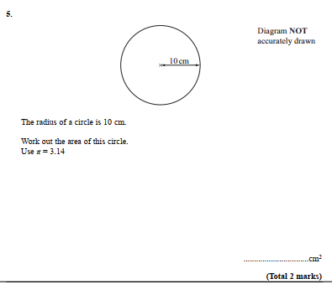

Pearson Edexcel - Friday 11 June 2010 - Paper 4 (Calculator) Higher Tier
8.
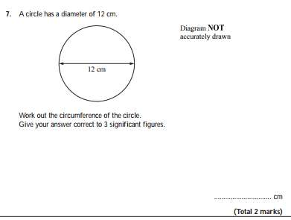
Pearson Edexcel - Tuesday 10 November 2009 - Paper 4 (Calculator) Higher Tier
9.
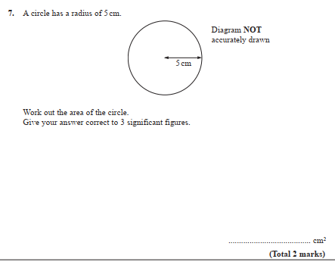
OCR GSCE – Monday 9 November 2020 – Paper 6 (Calculator) Higher Tier
10.
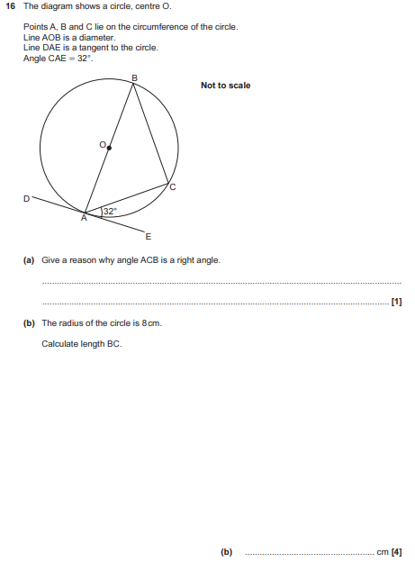

OCR GSCE – Thursday 24 May 2018 – Paper 4 (Calculator) Higher Tier
11.
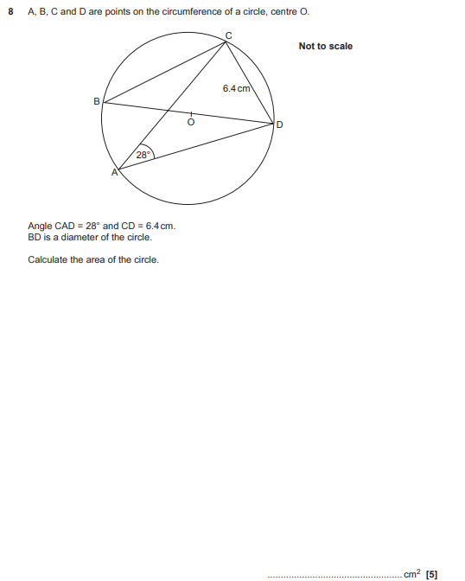

OCR GSCE – Thursday 8 June 2017 – Paper 5 (Non - Calculator) Higher Tier
12.
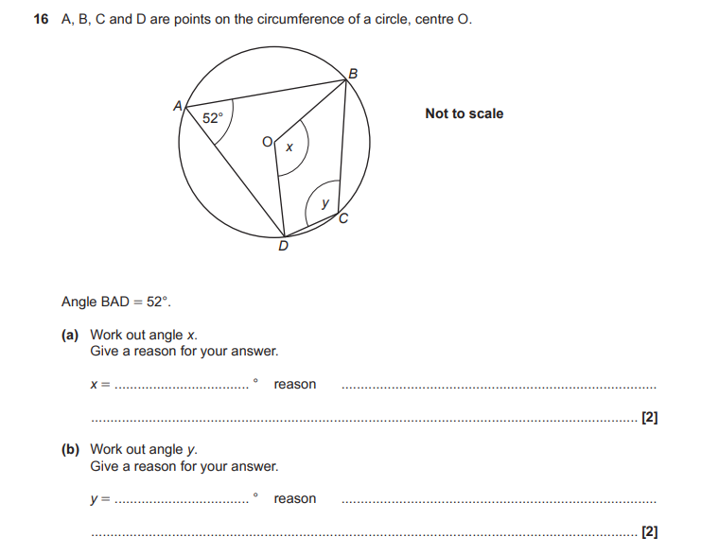

OCR GSCE – Sample Papers – Paper 5 (Non - Calculator) Higher Tier
13.
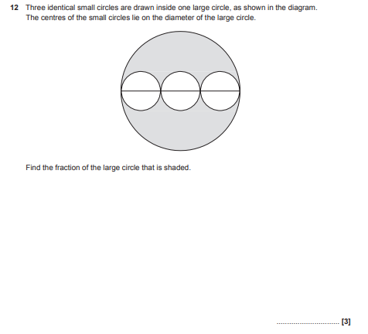

AQA GSCE – Tuesday 19 May 2020 – Paper 1 (Non - Calculator) Higher Tier
14.
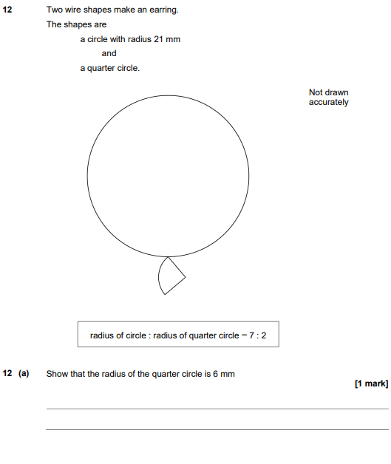

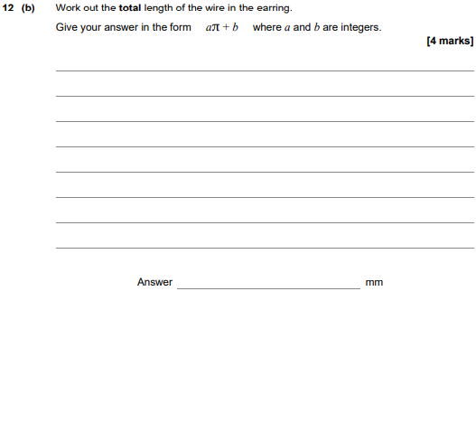

AQA GSCE – Thursday 8 June 2020 – Paper 3 (Calculator) Higher Tier
15.
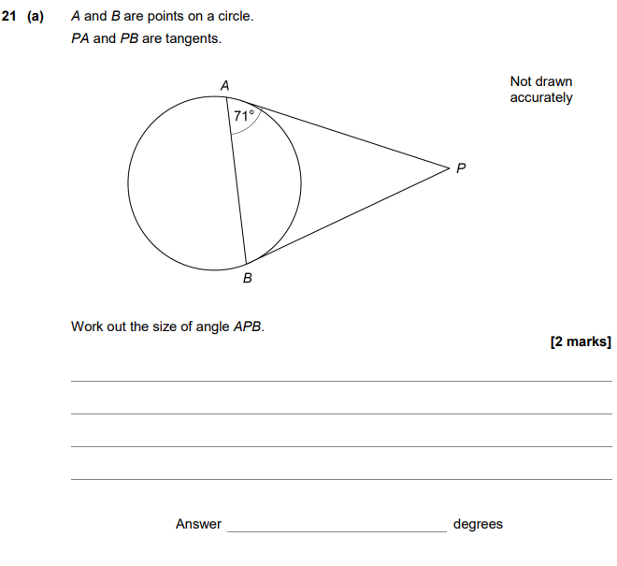
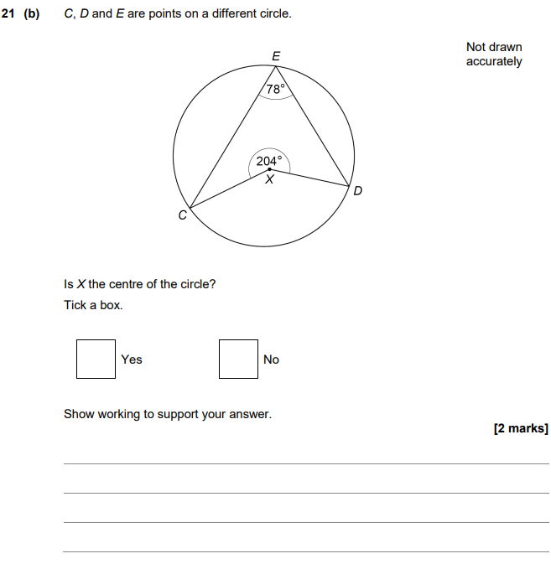

AQA GSCE – Tuesday 21 May 2019 – Paper 1 (Non - Calculator) Higher Tier
16.
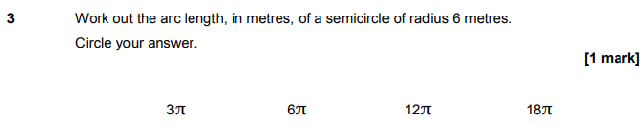
AQA GSCE – Tuesday 21 May 2019 – Paper 1 (Non - Calculator) Higher Tier
17.
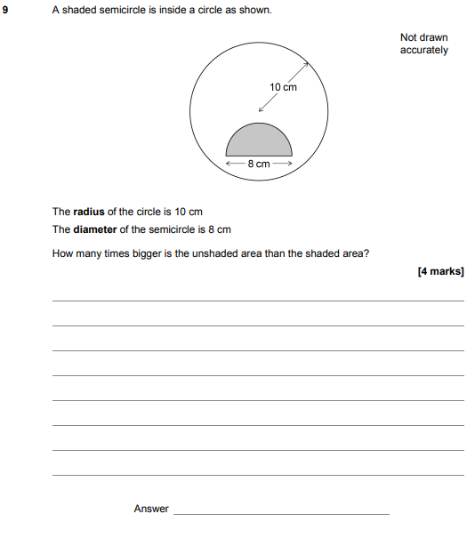

AQA GSCE – Tuesday 6 November 2018 – Paper 1 (Non - Calculator) Higher Tier
18.
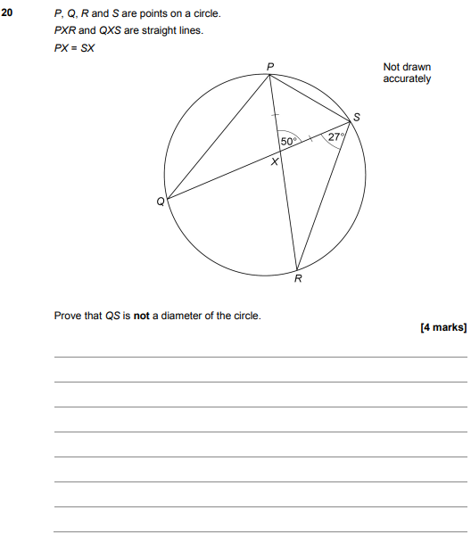

AQA GSCE – Thursday 8 November 2018 – Paper 2 (Calculator) Higher Tier
19.
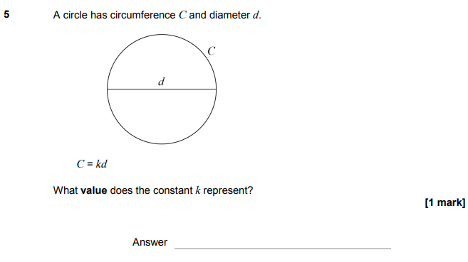

AQA GSCE – Monday 24 May 2018 – Paper 1 (Non - Calculator) Higher Tier
20.
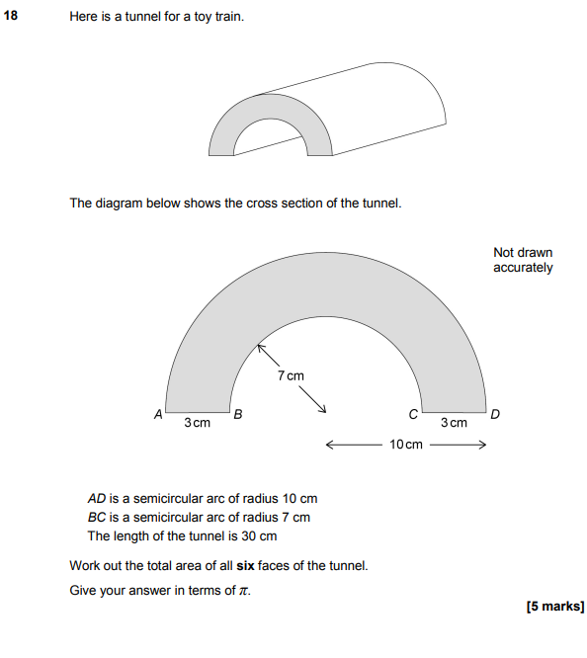

AQA GSCE – Thursday 7 June 2018 – Paper 2 (Calculator) Higher Tier
21.
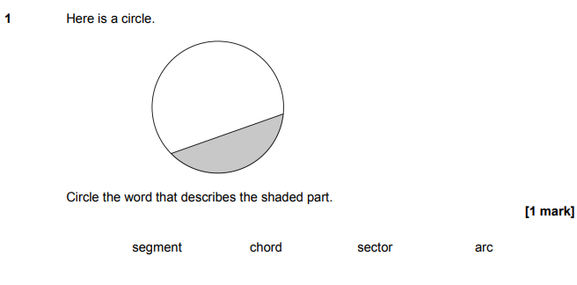
AQA GSCE – Thursday 7 June 2018 – Paper 2 (Calculator) Higher Tier
22.
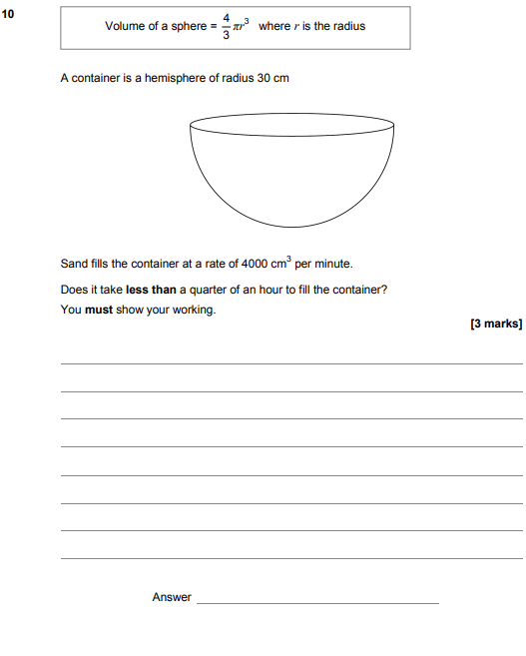

AQA GSCE – Thursday 8 June 2017 – Paper 2 (Calculator) Higher Tier
23.
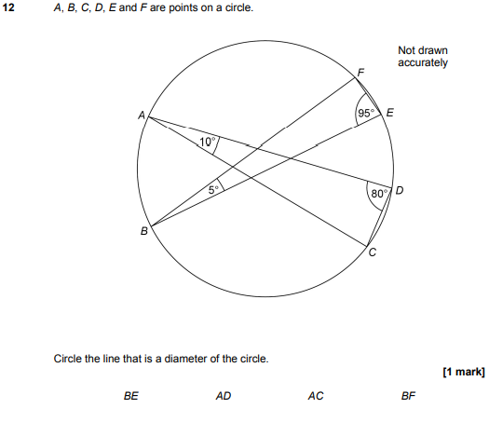

AQA GSCE – Sample Paper 1 (Non - Calculator) Higher Tier
24.
